**League of Legends Worlds 2021 Play-ins Portfolio Project**

**By Jackie Nguyen**

**Objective:**

The primary goal of this League of Legends 2021 Worlds Play-Ins analysis project is to delve into the intricacies of both individual player and collective team performance throughout the tournament. By employing advanced data analytics, we aim to unearth key performance indicators and trends that can offer actionable insights for various stakeholders:

**Players:** To identify areas for gameplay improvement.

**Team Owners and Managers:** To make informed decisions on player retention, recruitment, and roster changes.

**Contract Negotiations:** To provide data-backed evidence during salary negotiations, as tournament performance is often a critical factor in determining a player's market value.

**Dataset Focus**

The dataset under analysis comprises the following key metrics:

**Team:** The team participating in the match.

**Player:** Unique player identifier.

**Opponent_Team:** The opposing team.

**Position:** Role played in the game.

**Champion:** Character used in the match.

**Kills, Deaths, Assists:** Key performance indicators.

**Creep_Score:** Number of minions killed.

**Gold_Earned:** Total gold accumulated.

**Champion_Damage_Share:** Proportional damage contribution.

**Kill_Participation:** Ratio of kills and assists to the team's total kills.

**Ward Metrics:** Wards placed, destroyed, and interacted with.

**Objective Control:** Dragons and Barons slain or lost.

**Results:** Match outcome (Win or Loss).

**Tools**

The project utilizes SQL and Jupyter Notebooks for data aggregation and Tableau for data visualization, enabling us to present the data in a format that is both insightful and actionable for decision-making in the competitive gaming ecosystem.

**Team Sucess**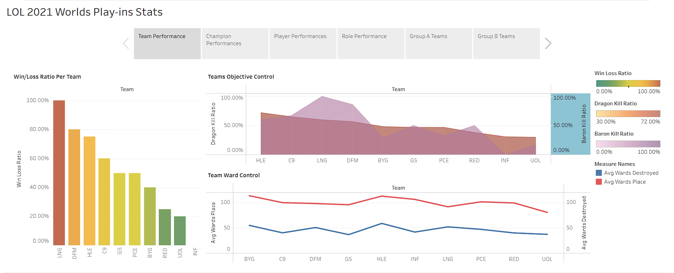

]

**Objective Control and Tournament Success**

Our analysis of the "Team Objective Control" and "Win/Loss Ratio Per Team" datasets reveals a striking correlation between objective control and tournament success. Specifically, the top four teams that advanced beyond the group stage and into the subsequent bracket consistently demonstrated superior control over key objectives like Dragons and Barons.

**The Paradox of Ward Score**

Interestingly, our "Ward Score" graph—which measures the frequency of placing and destroying wards—shows no significant correlation with winning games. This counterintuitive finding suggests that while warding is an essential aspect of gameplay, it's not the mere act of placing or destroying wards that matters.

**Strategic Implications:**

**Objective Control:** Teams aiming for tournament success should prioritize objective control, particularly over Dragons and Barons, as this appears to be a strong predictor of victory.

**Warding Strategy:** While warding remains crucial for map control and vision, our data suggests that the strategic placement and utilization of wards could be more impactful than the sheer volume of wards placed or destroyed.

**Holistic Approach:** Teams and players should adopt a playstyle that gives them priority to move first to objectives and to be able to set it up and secure objectives. This usually happens by drafting better bot lane champions with strong lane, and mids that can control area.

**Champion Winrates**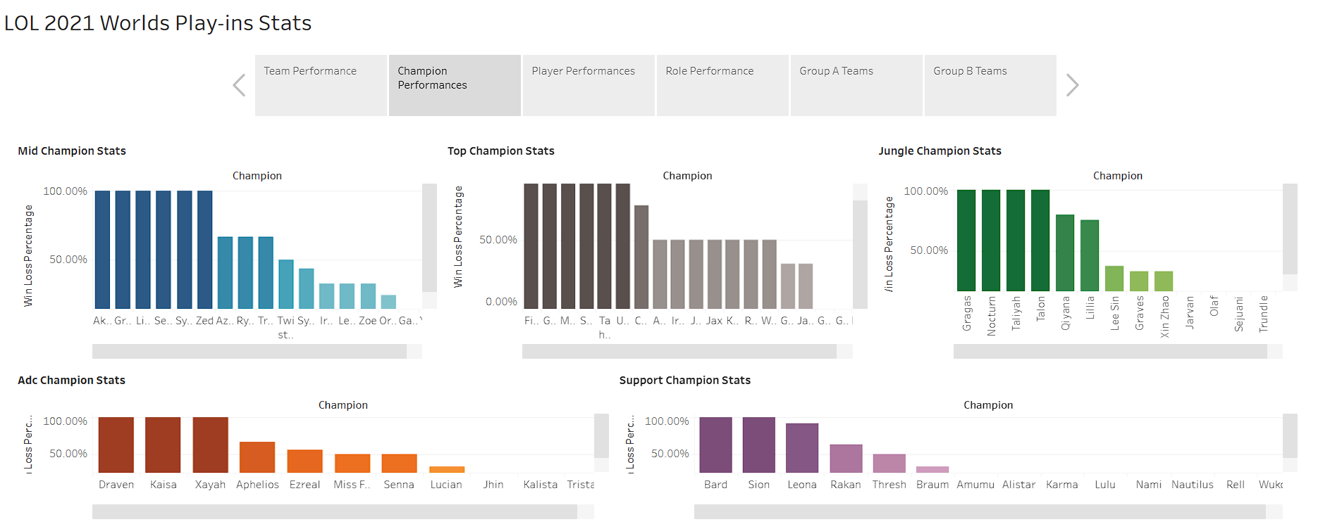

**The Power of Niche Picks**

While the data set may have limitations due to the small number of games for certain champions, it's worth noting that unique or niche picks can still be highly effective. If a player has mastered a specific champion and understands its utility in particular matchups and team compositions, then that champion becomes a viable pick.

**High-Impact Champions**

Our analysis reveals standout performances for certain champions:

**Leona:** Boasts a staggering 92% win rate over 13 games.

**Rakan:** Holds a solid 63% win rate across 8 games.

**Qiyana:** Achieved an 80% win rate in 5 games.

**Underperforming Picks**

Conversely, some popularly picked champions have not fared as well:

**Amumu:** A disappointing 13% win rate in 8 games.

**Xin Zhao:** A mere 33% win rate across 12 games.

**Lee Sin:** Struggles with a 38% win rate in 8 games.

**Jayce:** Holds a 33% win rate over 9 games.

**Sylas:** Manages a 44% win rate in 9 games.

**Strategic Implications:**

**Champion Mastery:** Players should not shy away from niche picks if they have a deep understanding of the champion's strengths and weaknesses.

**Meta Analysis:** Teams should consider the high-impact champions as priority picks or bans, given their proven success rates.

**Re-evaluation:** Popular but underperforming champions may need to be re-evaluated in terms of their actual utility and effectiveness in the current meta going into the Group Stage.

**Player Stats**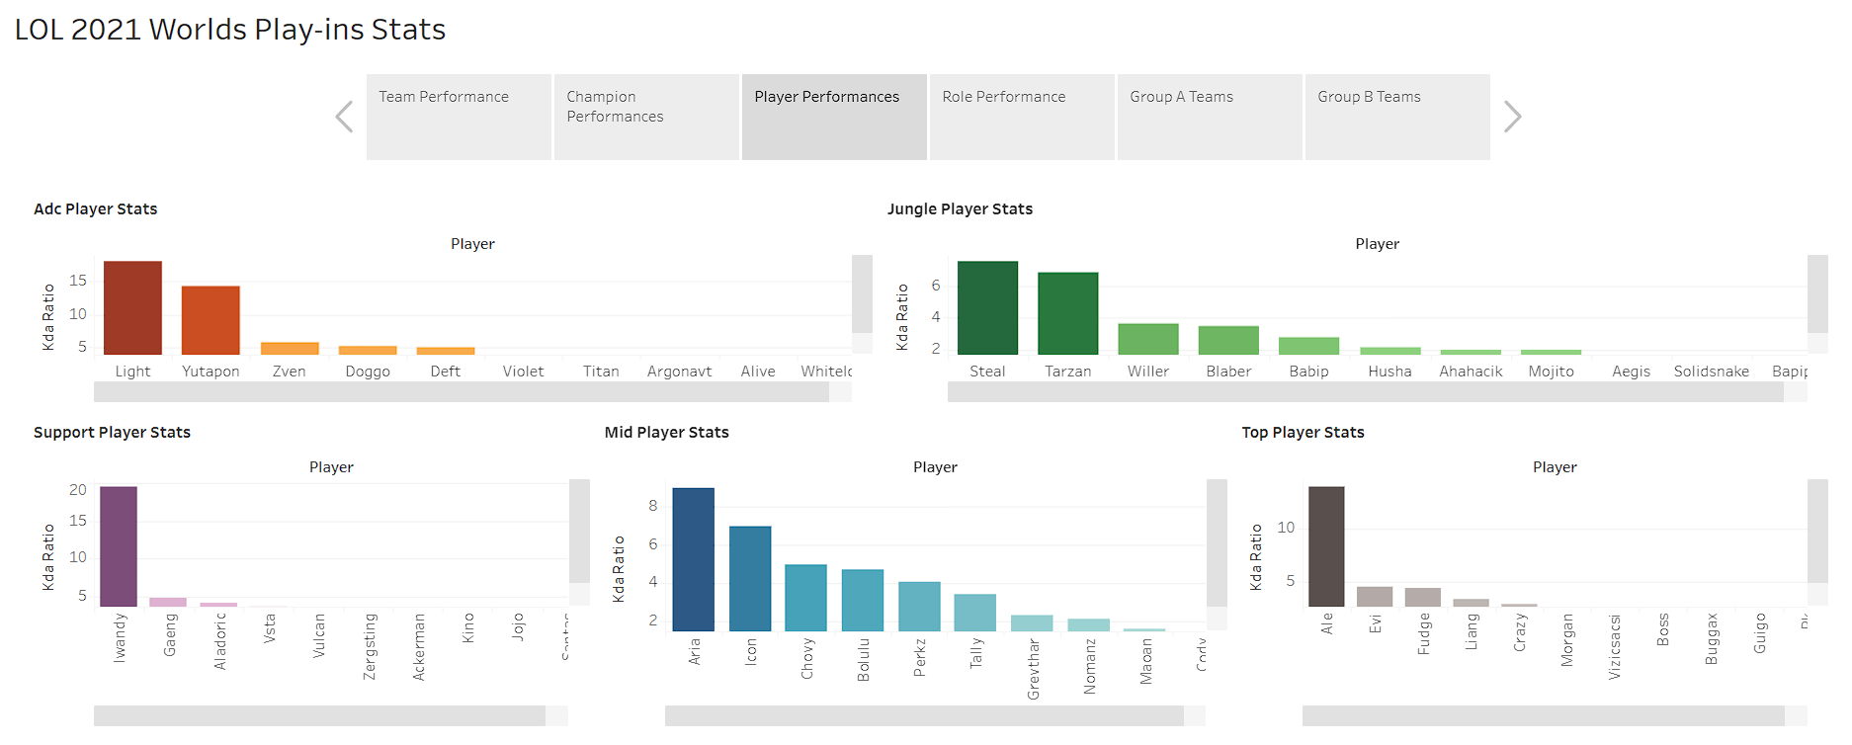

**Drafting and Pre-Match Strategy**

Analyzing individual player performance can offer invaluable insights for drafting and pre-match planning. While the top four mid-laners in the tournament show comparable performance levels, two players stand out in their respective roles:

**Iwandy:** The support player for LNG, significantly outperforms his competition.

**Ale:** The top-laner for LNG, also shows exceptional performance compared to peers.

Role-Specific Observations

Interestingly, junglers, whose primary role is to assist the team, have lower KDA ratios compared to their bot-lane and support counterparts. This suggests that many of the kills may have been solo efforts rather than team-coordinated plays.

**Strategic Implications:**

**Targeted Bans and Picks:** Going into the group stage, teams should consider targeted bans against standout players like Iwandy and Ale, preventing them from picking champions they are comfortable with or those considered overpowered in the current meta.

**Disruptive Gameplay:** Focus should also be on disrupting the gameplay of these key players, ensuring they are not enabled to make impactful plays.

**Role-Specific Strategies:** Given the lower KDA ratios for junglers, teams may want to reconsider their jungle-centric strategies and focus more on bot-lane and support roles for securing kills and objectives.

**Role Performance**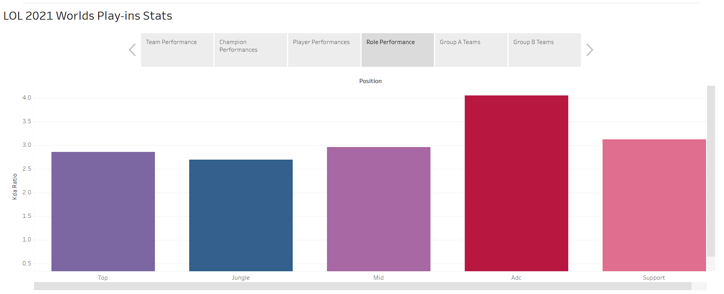

**ADC and Support Dominance**

Our data reveals that ADC (Attack Damage Carry) and Support roles consistently outperform other roles in terms of KDA ratio. This suggests a higher impact on the game's outcome from these roles, reinforcing the importance of the bot lane in the current meta.

**Underperforming Jungle Role**

Contrary to expectations, the Jungle role, traditionally considered a supporting or helping role, lags behind in KDA ratio when compared to Support, and even Top and Mid roles appear to perform at an average level.

**Strategic Implications:**

**Bot Lane Focus:** Given the high KDA ratios for ADC and Support roles, prioritizing strong picks like Leona or Rakan can be game-changing.

**Objective Conversion:** Selecting an ADC capable of efficiently converting kills into objectives—such as towers, Barons, and Dragons—can significantly increase the likelihood of securing a win.

**Rethinking Jungle Strategy:** The relatively lower KDA ratios for junglers may warrant a re-evaluation of jungle-centric strategies, possibly shifting focus towards champions only good early that enable their bot laners.

**Group A Stats**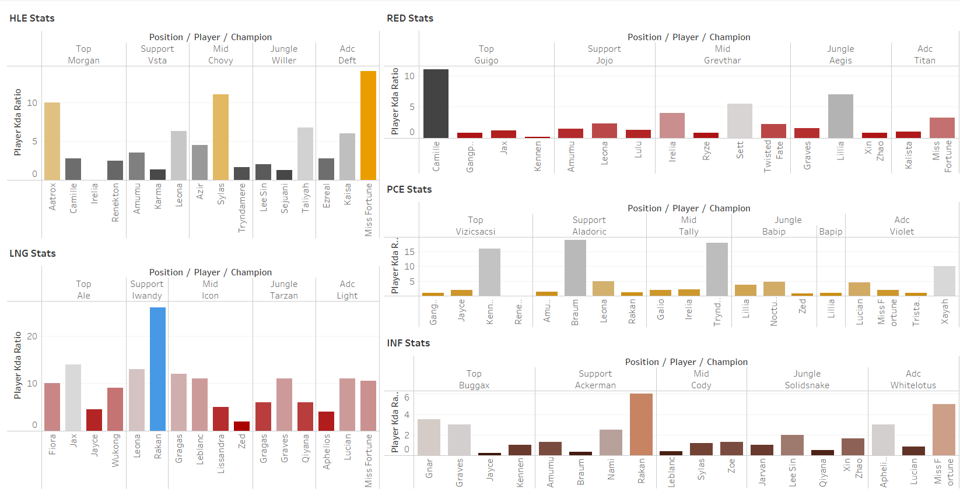

**Player-Specific Performance and Champion Dependency**

**Skill Versus Champion Reliance**

While statistics can sometimes be inflated due to individual skill—as evidenced by consistently strong performances from players on teams like HLE and LNG—our data indicates that players from other teams often rely heavily on their comfort picks to excel.

Case Studies

For example:

Guigo from RED: Shows a marked improvement in performance when playing Camille.

Tally from PCE: Tends to excel when using Tryndamere, especially in matches against other mid-tier teams.

**Strategic Implications:**

**Targeted Bans:** When facing teams with players who rely on specific champions, targeted bans can be an effective strategy to neutralize their impact.

**Drafting Strategy:** Teams like HLE and LNG, whose players perform consistently across multiple champions, may require a more nuanced drafting approach that considers team composition and counter-picks.

**Player Adaptability:** For teams with players reliant on comfort picks, developing proficiency in a broader champion pool could be a valuable long-term strategy to enhance adaptability and performance.

**Group B Stats**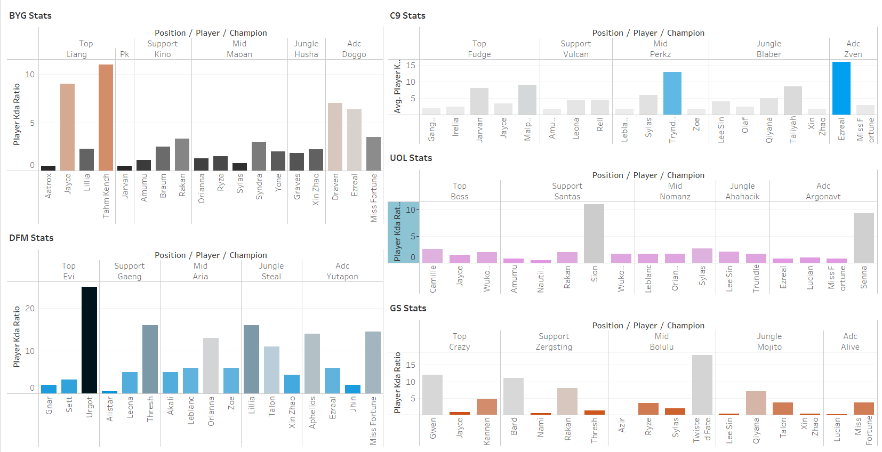

**Comparative Analysis of Group B**

**Regional Dominance**

While Group B mirrors some trends observed in Group A, it lacks the same level of domination from specific teams. Asian teams like HLE and LNG continue to outperform their North American and Japanese counterparts, such as C9 and DFM. However, the latter teams still exhibit the strength to advance beyond the play-ins stage.

**Standout Performances**

**Noteworthy individual performances include:**

**Evi's Urgot from DFM**: A champion pick that future opponents should consider carefully in their drafting strategy.

**Liang from BYG:** The top-laner has shown a level of performance that warrants attention, despite making it out of play-ins.

**Bolulu's Twisted Fate from GS:** Another player who has demonstrated skill worth noting for future matchups.

**Strategic Implications:**

**Drafting Caution:** Teams facing the winners of the play-ins should be cautious of standout players and their preferred champions, such as Evi's Urgot.

**Regional Considerations:** While Asian teams have historically performed well, it's crucial not to underestimate teams from other regions who have proven their ability to advance.

**Individual Threats:** Players like Liang and Bolulu have shown that they can be game-changers and should be accounted for in future game planning.

**Overall Analysis and Conclusion**

**Competitive Insights**

Our comprehensive data analysis of the League of Legends 2021 Worlds Play-Ins has yielded several actionable insights for teams looking to face off against specific powerhouses like HLE, LNG, C9, and DFM:

**Regional Strengths:** Asian teams HLE and LNG have consistently shown strong performances, making them formidable opponents. However, North American team C9 and Japanese team DFM have also proven their capability to advance beyond the play-ins, indicating that underestimating them would be a mistake.

**Player-Specific Strategies:** Key players like Evi from DFM with his Urgot, Liang from BYG, and Bolulu from GS with his Twisted Fate have shown standout performances. These players pose individual threats that should be carefully considered in drafting and gameplay strategies.

**Role Importance:** The ADC and Support roles have been particularly impactful, suggesting a bot-lane-focused meta. Conversely, the Jungle role has shown less influence on game outcomes, warranting a re-evaluation of Jungle-centric strategies.

**Champion Dependency:** While some players perform consistently across various champions, others are heavily reliant on comfort picks. Targeted bans against such players can be an effective strategy.

**Strategic Takeaways:**

**Drafting Strategy:** Consider targeted bans against standout players and their preferred champions. Also, adapt your drafting strategy based on the team's overall performance and champion flexibility.

**Game Planning:** Focus on disrupting key players and roles that have shown high impact, while also considering the strategic placement of objectives and wards.

**Adaptability:** Teams should be prepared to adapt their strategies based on real-time game developments, leveraging data-driven insights for optimal decision-making.

Off-Season and Future Team Building

**Player Transfers:** Standout players with exceptional performances have a strong case for negotiating better salaries or opting into higher-tier teams during the off-season.

**Team Strategy:** Teams looking to improve their roster for the next season should consider recruiting players who have shown consistent performances and adaptability, as these traits are invaluable for long-term success.

By taking these insights into account, teams can formulate more effective strategies for facing specific opponents, thereby increasing their chances of success in future matches. Additionally, standout players and teams can use this data for career and roster advancements, respectively.